**B3BD REGRESSION (logBB prediction from SMILES)**

1. **Chemprop:**

**MoleculeModel**(

(encoder): MPN(

(encoder): ModuleList(

(0): MPNEncoder(

(dropout): Dropout(p=0.3, inplace=False)

(act_func): ReLU()

(W_i): Linear(in_features=147, out_features=256, bias=False)

(W_h): Linear(in_features=256, out_features=256, bias=False)

(W_o): Linear(in_features=389, out_features=256, bias=True)

)

)

)

(readout): Sequential(

(0): Dropout(p=0.3, inplace=False)

(1): Linear(in_features=256, out_features=256, bias=True)

(2): ReLU()

(3): Dropout(p=0.3, inplace=False)

(4): Linear(in_features=256, out_features=1, bias=True)

)

)

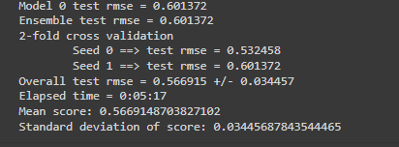

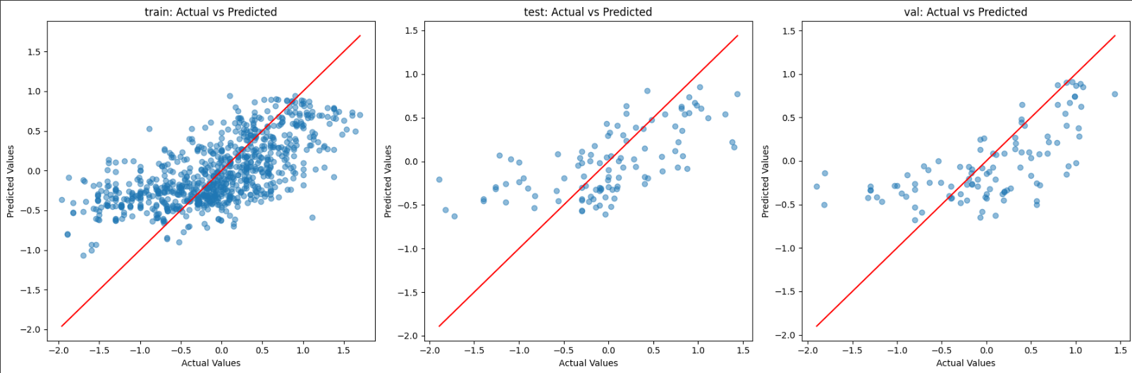

1. **GraphConvModel from deepchem:**

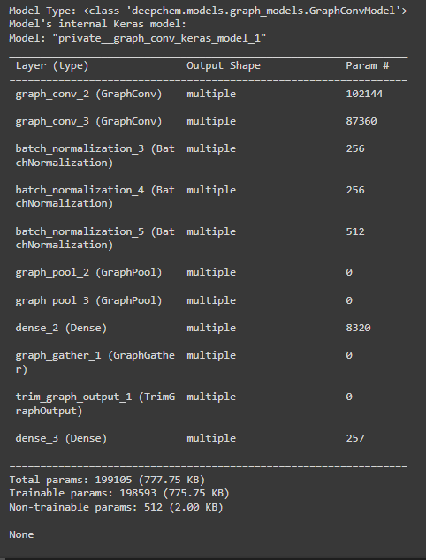

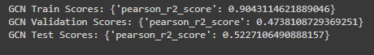

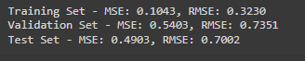

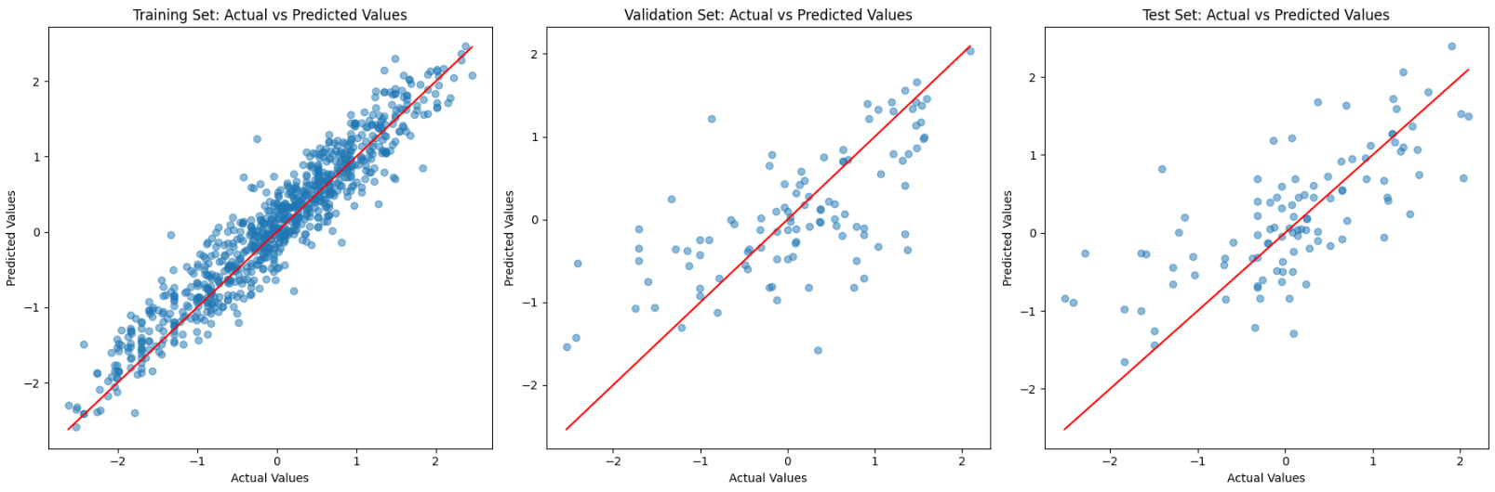

1. **MPNN from rdkit:**

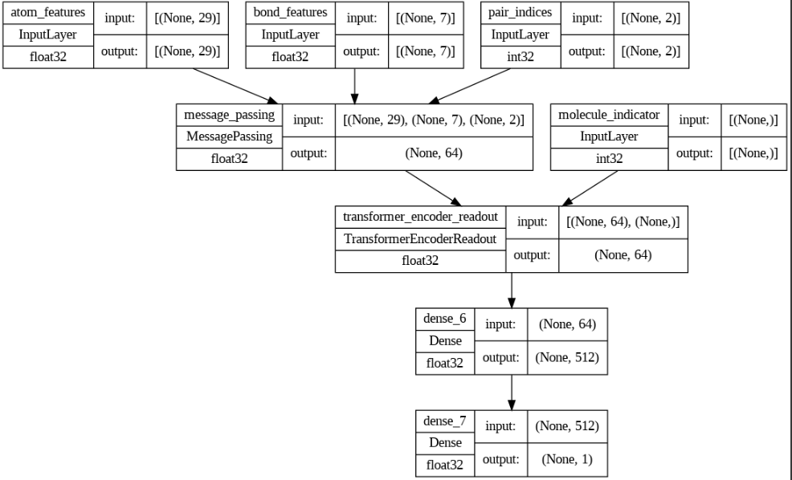

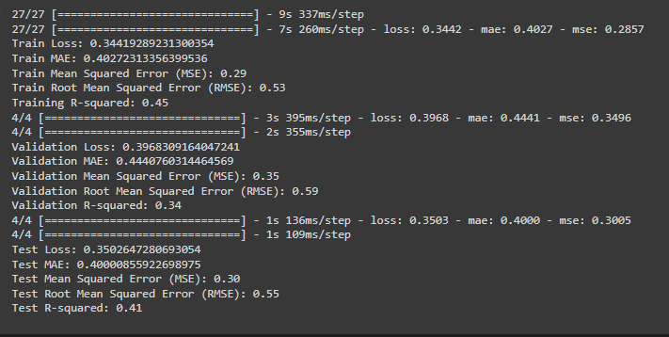

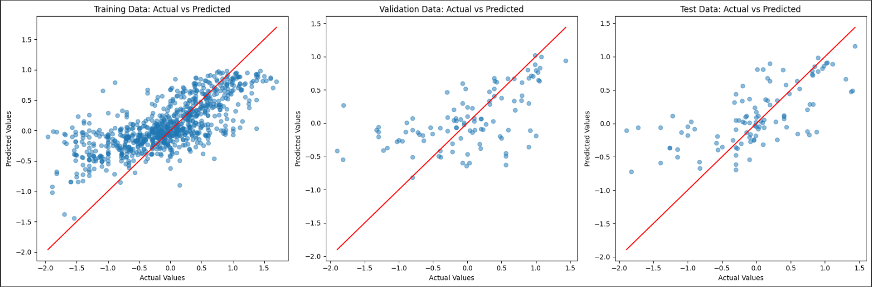

1. **WeaveModel from deepchem:**

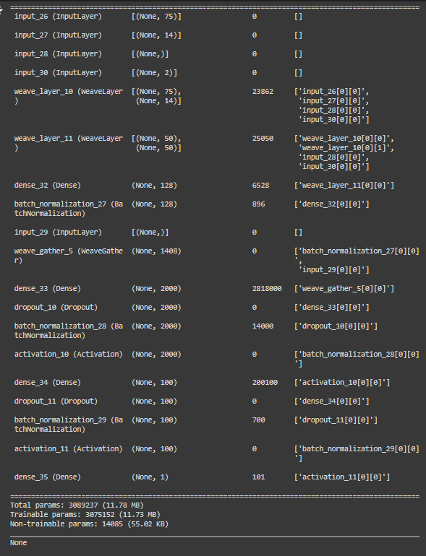





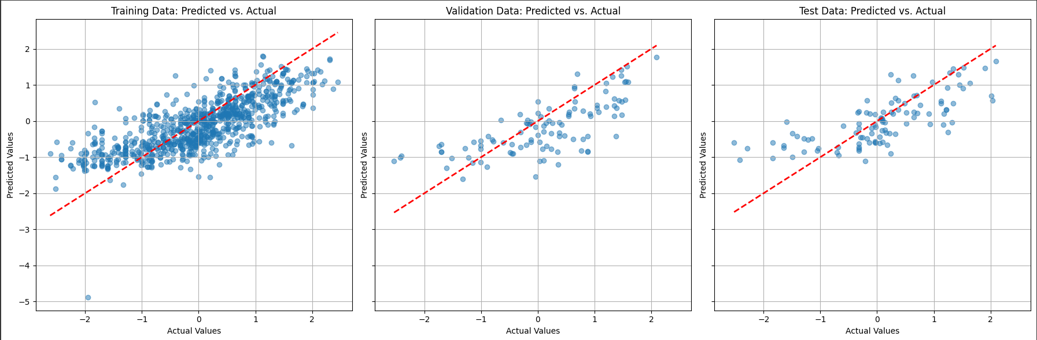

**graph convmodel:**

